HOME OF NANA KWAME

50 Best Success Quotes of All Time
Under30CEO | August 24, 2011 | 28 Comments
Read: 100 Things You Need to Know as a Young Entrepreneur
1. “Identify your problems but give your power and energy to solutions. 2. “You live longer once you realize that any time spent being unhappy is wasted.”
3. “The only true wisdom is knowing that you know nothing.” Socrates
4. “Things work out best for those who make the best of how things work out.”

5. “Let no feeling of discouragement prey upon you, and in the end you are sure to succeed.”
6. ” If you are not willing to risk the usual you will have to settle for the ordinary.”
7. “Trust because you are willing to accept the risk, not because it’s safe or certain.” Anonymous
8. “When your life flashes before your eyes, make sure you’ve got plenty to watch.” Anonymous
9. “Screw it, let’s do it!”
10. “Be content to act, and leave the talking to others.”
11. “Innovation distinguishes between a leader and a follower.”
12. “The more you loose yourself in something bigger than yourself, the more energy you will have.” Norman Vincent Peale

13. “If your ship doesn’t come in, swim out to meet it!”
14. “People often say that motivation doesn’t last. Well, neither does bathing – that’s why we recommend it daily.”
15. “Courage is being scared to death, but saddling up anyway.” John Wayne
16.“Too many of us are not living our dreams because we are living our fears.” Les Brown

17. “The link between my experience as an entrepreneur and that of a politician is all in one word: freedom.”
18. “The entrepreneur builds an enterprise; the technician builds a job.” Michael Gerber
19. “A real entrepreneur is somebody who has no safety net underneath them.” Henry Kravis
20. “Most new jobs won’t come from our biggest employers. They will come from our smallest. We’ve got to do everything we can to make entrepreneurial dreams a reality.” Ross Perot
21. “My son is now an ‘entrepreneur’. That’s what you’re called when you don’t have a job.” Ted Turner

22. “As we look ahead into the next century, leaders will be those who empower others.”
23. “As long as you’re going to be thinking anyway, think big.” Donald Trump
24. “If you want to achieve excellence, you can get there today. As of this second, quit doing less-than-excellent work.” Thomas J Watson
25. “Opportunity is missed by most people because it is dressed in overalls and looks like work.” Thomas Edison
26. “The only place where success comes before work is in the dictionary.” Vidal Sassoon
27. “Capital isn’t scarce; vision is.” Sam Walton

28. “Failure defeats losers, failure inspires winners.”
29. “Some people dream of great accomplishments, while others stay awake and do them.” Anonymous
30. “I will tell you how to become rich. Close the doors. Be fearful when others are greedy. Be greedy when others are fearful.” Warren Buffet
31. “Going into business for yourself, becoming an entrepreneur, is the modern-day equivalent of pioneering on the old frontier.” Paula Nelson
32. “Poor people have big TV. Rich people have big library.” Jim Rohn
33. “A goal is a dream with a deadline.” Napoleon Hill
34. “Every day I get up and look through the Forbes list of the richest people in America. If I’m not there, I go to work.” Vinnie Rege

35. “Expect the best. Prepare for the worst. Capitalize on what comes.”
36. “People are not lazy. They simply have important goals – that is, goals that do not inspire them.” Tony Robbins
37. “Nobody talks of entrepreneurship as survival, but that’s exactly what it is.” Anita Roddick
38. “The best reason to start an organization is to make meaning; to create a product or service to make the world a better place.” Guy Kawasaki
39. “A friendship founded on business is a good deal better than a business founded on friendship.” John D. Rockefeller
40. “I’ve been blessed to find people who are smarter than I am, and they help me to execute the vision I have.” Russell Simmons
41. “I find that when you have a real interest in life and a curious life, that sleep is not the most important thing.” Martha Stewart
42. “Logic will get you from A to B. Imagination will take you everywhere.” Albert Einstein
43. “Success is liking yourself, liking what you do, and liking how you do it.” Maya Angelou
44. “Success is walking from failure to failure with no loss of enthusiasm.” Winston Churchill
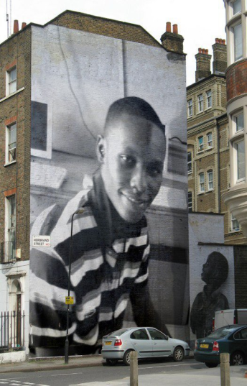
45. “The function of leadership is to produce more leaders, not more followers.” Ralph Nader
46. “Without continual growth and progress, such words as improvement, achievement, and success have no meaning.” Benjamin Franklin
47. “Big pay and little responsibility are circumstances seldom found together.” Napoleon Hill
48. Make your product easier to buy than your competition, or you will find your customers buying from them, not you.” Mark Cuban
49. “The road to success and the road to failure are almost exactly the same.” Colin R. Davis
50. “If you don’t have a competitive advantage, don’t compete.”
nanakwame@ownmail.net
aity27@yahoo.co.uk

